1. Explain about Supervised Machine Learning?





1. Explain about K-Nearest Neighbours?



1. Failure cases of KNN?



1. Define Distance measures: Euclidean(L2) , Manhattan(L1), Minkowski,  Hamming?



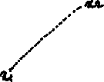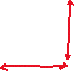

1. What is Cosine Distance & Cosine Similarity?



1. How to measure the effectiveness of k-NN?



1. Limitations of KNN?

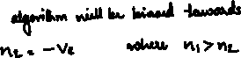

1. **How to handle Overfitting and Underfitting in KNN?**

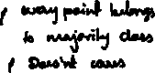

1. **Need for Cross validation?**



1. **What is K-fold cross validation?**

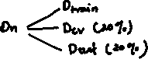

|  |  |  |  |
| --- | --- | --- | --- |
| **Fold** | **Train** | **CV** | **accuracy** |
| K1 | D1, D2, D3 | D4 | A4 |
| K2 | D1, D2, D4 | D3 | A3 |
| K3 | D1, D3, D4 | D2 | A2 |
| K4 | D2, D3, D4 | D1 | A1 |



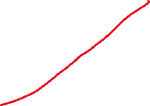

1. **What is Time based splitting?**

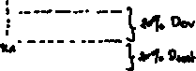

1. **Explain k-NN for regression?**



1. **What is Weighted k-NN?**



|  |  |  |  |
| --- | --- | --- | --- |
|  |  |  |  |
|  |  |  |  |
|  |  |  |  |
|  |  |  |  |
|  |  |  |  |



1. **How to build a kd-tree?**



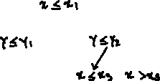

1. **What is Locality sensitive Hashing (LSH)? (Hashing vs LSH?**

|  |  |
| --- | --- |
|  |  |
|  |  |
|  |  |
|  |  |



1. **LSH for cosine similarity?**

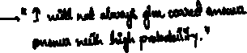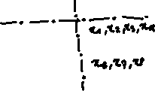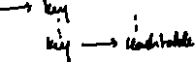

1. **LSH for Euclidean distance?**

